|  |
| --- |
|  |
| Experience from Sweden in CAVs operational safety |
| A comparative study between Gothenburg and Oxford |
| **Weicheng Zhang**  **Jinhao Wang** |
| **Yiyang Li**  **Yinying Li** |
| **28th Aug, 2019** |

# Abstract

This report is a case study of Sweden in respect of Connected and Autonomous Vehicles (CAVs), focusing on operational safety. Using an integrated methodology to analyse related policies in Sweden, the research also compares the current development of CAVs between Oxford and a Swedish city—Gothenburg. The structure of the report is as follows:   
 First, the summary of Swedish policies related to autonomous vehicles. Then, the factors directly and indirectly affect operational safety is identified. It is found that infrastructure is the most important factors to ensure safety. Thus, the comparative study is mainly focus on the aspect of infrastructure between Gothenburg and Oxford. And finally, the proposal is based on the comparison, including what experience Oxford can gain from Gothenburg. A short-term and long-term plan for the Oxford City Council and Oxfordshire County Council is recommended.

# Catalogue

Abstract 1

Catalogue 2

1 Introduction 3

1.1 Operational safety---the key to the development of CAVs 3

1.2 Reason for choosing Sweden 3

2 Methodology 4

2.1 Literature Review 4

2.2 Factor Analysis 4

2.3 Comparative study 4

2.4 Spatial Analysis 4

3 Sweden Current Situation in CAVs 4

3.1 Sweden related policies and projects 5

3.2 Gothenburg related policies and projects 6

3.3 Safety test 6

4 Factor Analysis 7

4.1 Analysis Aim 7

4.2 Analysis Method 8

4.3 Conclusion 8

Factors Found 8

Order of Factor Significance 8

4.4 Indicators of CAV infrastructure evaluation 10

Density of Electrical Vehicles (EV) charging station 10

Quality of mobile internet 12

4G coverage 12

Logistic Infrastructure 13

Technology infrastructure change readiness 14

Overall image of indicators comparison 15

5 Comparative study between Oxford and Gothenburg 15

6 Proposal 19

6.1 Short term plan: 2020-2025 19

6.2 Long term plan for CAVs 21

7 Conclusion 21

8 References and Bibliography 22

# Introduction

* 1. Operational safety---the key to the development of CAVs

The continuing evolution of connected autonomous vehicles (CAVs) impels countries around the world to develop a relevant national strategy. Even though autonomous vehicles are designed to be capable of safely completing journeys without the need for a driver in all normally encountered traffic, road and weather conditions (DfT, 2015), as with any innovation, they have faced many technological problems in real-world operations, and social and ethical controversy as well. Safety issue is one of which people concern a lot. That doesn’t only mean the safety of just the drivers and passengers, but also other vehicles on the road, pedestrians, and bicycle traffic, etc. Automotive driving process requires a great deal of decision making, and there are many unpredictable factors that may affect it. Therefore, the development of CAVs must be mainly guided by the government to ensure operational safety.

Understanding operational safety means also taking on a thicket of technological and policy-related challenges. Oxford City Council is developing the vision of connected and autonomous vehicles, which could revolutionise people’s lives. Before the fleet change in reality, it is of paramount importance to find out what factors contribute to safety problems and how to solve them. We believe Oxford is uniquely positioned to become a premium location globally for the development of CAVs, but learning from other places which have already taken steps to amend their policies and legislative framework is also a necessary process while formulating policy and conducting related projects in Oxford City Council and Oxfordshire County Council. This research involves an international study of guidance and policies related to CAVs, targeting one European country. Sweden is chosen in this report and the reasons are illustrated in the following section.

* 1. Reason for choosing Sweden

Sweden has recognised the importance of ensuring the regulatory environment is suitable to allow the development of CAVs technologies. Autonomous transport technologies are regarded as enablers to meeting target of reduction in carbon emissions and “vision zero” – where nobody is killed in road collisions – by 2050. After adopting the Vision Zero plan early in 1997, Sweden has consistently registered the world’s lowest numbers of traffic fatalities in relation to its population, and roads are the world's safest (the Economist, 2014). Safety is always prioritized over speed, convenience and other factors in Sweden, but this doesn’t hinder the government to conduct trials in autonomous vehicles under risk and uncertainty. There must be some secrets to ensure operational safety that other places can learn from.

In international comparisons, Sweden perform well in relation to policy frameworks that enable innovation and a strong track record in digital infrastructure. Sweden ranked top 5 in the Autonomous Vehicles Readiness Index (AVRI), which is a tool provided by KPMG to help measure level of preparedness for autonomous vehicles. (KPMG, 2019). In the city level, the transport agency has already permitted small-scale Autonomous Vehicles (AV) pilots, including a driverless bus running on a 1.5 kilometres section of public road in northern Stockholm and a self-driving shuttle in Gothenburg. Also, Gothenburg is the first city to incorporate autonomous vehicles into urban planning, creating a milestone for city’s long-term planning in the field of autonomous vehicles.

Sweden’s reputation for innovative technology as well as having excellent road and mobile network infrastructure makes it a leading model to learn and gain experience from. And Gothenburg is the CAVs pioneer city in Sweden, so it would be the city mainly discussed and used as a benchmarking city that compare with Oxford in this report. For the aim of this research, a policy proposal to improve operational safety is being recommended for the Oxford City Council, based on the case study in Sweden and comparative study between Oxford and Gothenburg..

# Methodology

2. 1. Literature Review

To start the research, a literature review of international experience was undertaken. Policies and projects, from national to city scale, related autonomous vehicles was collected and summarised. The planning documents and strategies in Gothenburg and safety tests are also important part of the review to provide the whole understanding of the development situation.

2. 2. Factor Analysis

After summarising the policies, projects and safety tests in Sweden, mainly in Gothenburg, direct and indirect factors leading to safety problems are identified. We conducted factor analysis, which is commonly used in policy-related research by reducing the large number of variables into few underlying factors to explain the group characteristics. This is a multivariate technique used to help to efficiently discern which criteria Sweden government emphasises and how they affect the implementation.

1. 3. Comparative study

There must be lessons to learn from Gothenburg, but not copying the whole. Since each city has its own characteristics and policy-makers need to come up with policies according to the city development. It is necessary to compare the similarity and differences between two cities in order to sum up what Oxford can learn from Gothenburg and what policies need to adjust to local conditions.

* 1. Spatial Analysis

In Gothenburg, shared shuttles of level 2 automation have been put into practice. ArcGIS is used to analyze the road speed limitation, the density of conventional bus stations and roads within the central area of the two compared cities. According to the spatial similarities, a possible place for real road test in Oxford is chosen.

# Sweden Current Situation in CAVs

Various policies instruments are used in Sweden in order to achieve autonomous vehicle operational safety. Many major research and development projects in respect of AV are also being carried out. This section is going to summarise different policies, projects from national to city scale. Most of the projects were hold by the Swedish Transport Agency, which has the regulatory responsibility and is heavily involved in the developments and negotiations. City of Gothenburg is also the main responsible stakeholders to initiate different policies. The following table shows three categories, including Sweden related policies and CAV projects from a national scale, Gothenburg related policies and CAV projects from a city scale, and also safety tests in Gothenburg. Some examples are listed to show how autonomous vehicles have been developed in Sweden. The whole table can be seen in the Appendix(



Gothenburg related policies and projects)

|  |  |  |  |
| --- | --- | --- | --- |
| **Catalogue** | **Example** | **Remark** | **Total number of policies studied** |
| **Sweden related policies and projects** | AVTCT | To understand the role of a traffic control tower (TCT) for automated road vehicles (AVs). | 12 |
| SARTRE (Safe Road Trains for the Environment) Project | An EU-financed project to ensure that hardware and software work safely and suitable to the existing infrastructure. |
| **Gothenburg related policies and projects** | Gothenburg Comprehensive Plan | Autonomous Vehicles as part of comprehensive plan for city centre | 5 |
| Shared Shuttle Services (S3) | An autonomous shuttle bus is available to the public in the campus of university |
| Drive Me Project | 100 self-driving Volvo cars will be driven on public roads in Gothenburg |
| **Safety tests in Gothenburg** | HEADSTART | Define testing and validation procedures of connected and autonomous driving functions | 3 |

Table 3-1. Current CAV progress made by Sweden

3. 1. Sweden related policies and projects

For example, CAV(Connected and Autonomous Truck)project will demonstrate how driverless truck transport can be enabled by enhanced connectivity based on 5G, connected services and ecosystem and remote operation of vehicles. Developed services will be made available through Drive Sweden Innovation Cloud to enable additional innovation, demonstrations and dissemination of [results.The](https://wx2.qq.com/cgi-bin/mmwebwx-bin/webwxcheckurl?requrl=http%3A%2F%2Fresults.The&skey=%40crypt_4a100cb5_01aacf750c7534550fe473dac294ab1c&deviceid=e558783870595507&pass_ticket=Ji1WMNsKgSblfm%252BK4NRgFYXPTXbGzHeVM7o87vCPplsNdbZ%252BJaR1nbA6FBrl7n7T&opcode=2&scene=1&username=@048ed41faeb67f7b9ecc8010d3b11075cb4914b7c15195183d2efe79bb896d98) purpose of the HUGO project, and the long-term goal, is to explore new innovative and environmentally friendly ways of performing the last mile deliveries. The project was to go from idea to finished prototype by exploring, investigating and building a self-driving last-mile robot to solve the problem of costly, time-consuming and environmentally friendly transports

# Gothenburg related policies and projects

Gothenburg City Planning Authority is the first in the world to examine the interaction between autonomous vehicles and sustainable, long-term urban planning. It is groundbreaking to see autonomous vehicle is part of the transport strategy, aiming to achieve high degree of autonomation and sustainable goals like reducing carbon dioxide. The city is exploring the effects and benefits of technology, including, but not limited to, the future need for parking facilities, enhanced road safety, accessibility. Interdependencies between the technology associated with autonomous vehicles and transport systems are the trend of development. The continued planning in Gothenburg would primarily focus on supplementing the existing infrastructure for CAVs. When building ad­ditional structures, it is important to consider poten­tial conflicts between CAV and non CAVs. Reduce the need for a significant amount of infrastructure change is also reasonable.

Another projects worth mentioning is called Drive Me. The Drive Me pilot project in Gothenburg is the first in a number of planned public trials with autonomous driving Volvo cars. City of Gothenburg cooperate with Volvo who is the industry leader in the area of automotive safety. It is believed that the introduction of Autonomous Driving (AD) technology promises to reduce car accidents. Furthermore, AD technology promises to free up congested roads, reduce pollution and allows drivers to use their time in their cars more valuably. Drive Me project is a customer-focused approach. Instead of relying purely on the research of its own engineers, it aims to collect feedback and inputs from real customers using these autonomous cars in their everyday lives.

1. 1. Safety test

A big-scale project funded by European Union with 17 members is aiming to harmonize European solutions for testing automated road transport, and operational safety is one of the key topics it focus on (HEADSTART[Harmonized European Solutions for Testing Automated Road Transport], <https://www.headstart-project.eu/>, 2019) . Established in January 2019 and lasting for 36 months, the project aims to define testing and validation procedures of connected and autonomous driving functions including key technologies such as v2x communications, cyber-security and positioning(three significant characteristics for safety reliability),. Furthermore, it aims to create an assessment protocols to increase vehicle safety awareness and intends to generate regulations to promote safe introduction of autonomous vehicles to the market. Meanwhile, it creates an assessment protocols to increase vehicle safety awareness and intend to generate regulation to promote safe introduction of autonomous vehicles to the market. (Detailed information could be viewed in Appendix)

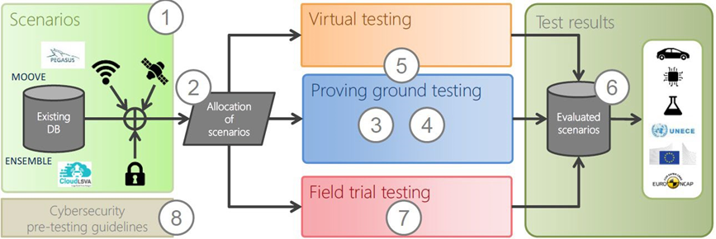

Figure 3.3-1. project concept of HEADSTART <https://www.headstart-project.eu/results-to-date/presentations/>

Test sites

HEADSTART now owns 5 test sites and AstaZero is the one that involves the state-owned [Research Institutes of Sweden](https://www.ri.se/en)(RISE) and [Chalmers University of Technology](https://www.chalmers.se/en/Pages/default.aspx).

Facility of AstaZero features a track that takes advantage of the combination of virtual traffic system, human beings and test vehicle to form a new realistic environment. The major testing aim of AstaZero is active safety which is about avoiding collisions and other incidents before they happen. Based on this fundamental aim and provided year-round testing, the site will study diver behaviour, detection for false alarm and crash contact point optimization.

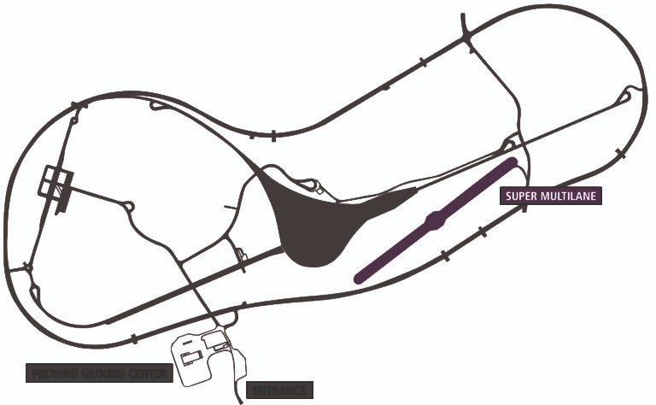

Figure 3.3-2. super-multilane design of AstaZero site <http://www.astazero.com/super-multilane/>

Another test site belongs to Applus + IDIADA, situated in the technology centre near Barcelona,  including the most comprehensive independent testing ground, testing laboratories and vehicle development centre for motor vehicles in Europe. In terms of operational safety, the site leads projects such as vehicle-to-vehicle emergency braking systems for CAV application and pedestrian detection system to guarantee the mass security.

# Factor Analysis

* 1. Analysis Aim

Through the summary of all the policy, research and projects conducted by Swedish government regarding to the safe operation of CAVs, we can discover that each item owns its emphasis, which draws the most intention of the researcher or policy maker. For example, in the case of Shared Shuttle Services (S3) project implemented in Gothenburg, Sweden, the main purpose of the appliance of such service is to test the needed infrastructure and management system, as well as to give public opportunities to experience autonomous transportation.

Factors gains most concerns from people can be considered to be of most significance. Factors imply what status the policy and projects most attend to change and what puzzle the research most would like to demonstrate when forcing to promote CAVs. As an interaction, these factors also constrain the efforts to enhance the operational safety of CAVs. Infrastructure inadequacy determined that S3 project can only install the routes of autonomous shuttle buses on roads in relatively fine condition. Similar examples can be readily found in the difficulties the governments face when they put policy into effect.

Therefore, to better understand what has the maximum impact on the operational safety of CAVs, factors should be extracted from the description of each policy, research or projects. Not only should what factor exists be verified, the order of its importance also need to be ascertained. Then based on the analysis of factors, we can track the operating conditions of Oxford over several dimensions more effectively, through a comparative study with Gothenburg, a world-leading city of CAV adoption.

* 1. Analysis Method

Principle component analysis and cluster analysis is utilized in this case of study to use a few factors to describe the relationship between many items. That is, each items’ description is checked to figure out variables influence its planning and implementation. Several closely related variables are grouped in the same category, and each category of variables becomes a factor, reflecting most of the information of the original data. Each factor is independent of the other.

After the factors were identified, the frequency of different factors is calculated. The factor with higher frequency is deemed as more important, and the order of factor significance is reached by sorting the frequency.

* 1. Conclusion

Factors Found

6 factors were extracted from the detailed content of all the policy: infrastructure, management, social awareness, safety test and collaboration and financial incentives. Infrastructure implicate the base facilities that support the operation of CAVs, including road design, authorized area for CAVs like parking lot and station, equipment like charging point. Management incorporates route management, data management, arrangement for timetable of autonomous bus operation. Social awareness includes social acceptance and participation, which means what do people think of CAV and the willingness of people to experience CAV operation. Collaboration as sharing data and relevant standard is also taken into consideration. And financial incentives mean government’s fiscal appropriation for CAV programs.

Order of Factor Significance

By comparing the frequencies, we obtained the order of factor significance. Infrastructure ranks NO.1 with the frequency of 17, followed by management. Safety test and collaboration tied for third, then the social awareness. Financial incentives is considered as the least important.

|  |  |  |  |  |  |  |
| --- | --- | --- | --- | --- | --- | --- |
| Project/research name | Infrastructure | Management | Safe test | Social awareness | Collaboration | Financial incentives |
| Autopilot in Barkaby | 1 | 1 | 1 | 1 |  |  |
| Autopilot in the Nordic countries | 1 | 1 | 1 | 1 |  |  |
| Shared Shuttle Services (S3) | 1 | 1 | 1 | 1 |  | 1 |
| KOMPIS | 1 |  |  |  | 1 |  |
| Autonomous transport system | 1 |  |  |  | 1 |  |
| AVTCT | 1 | 1 |  |  |  |  |
| CAT | 1 | 1 |  |  |  |  |
| HUGO | 1 | 1 |  |  |  |  |
| Automated logistics services | 1 | 1 |  |  |  |  |
| ART | 1 | 1 |  |  |  |  |
| Advanced Cooperative Driver Assistance | 1 |  | 1 |  | 1 |  |
| Interlink |  | 1 |  |  | 1 |  |
| Traffic management of emergency vehicles |  | 1 |  |  | 1 |  |
| Gothenburg Comprehensive Plan | 1 |  |  |  |  |  |
| Development strategy Gothenburg 2035 | 1 |  |  |  |  |  |
| The transport strategy 2035 | 1 |  |  |  |  |  |
| The green strategy | 1 |  |  |  |  |  |
| DriveMe | 1 | 1 | 1 |  | 1 |  |
| SARTRE project | 1 |  | 1 |  |  |  |
| Applus + IDIADA | 1 |  | 1 |  | 1 |  |
| HEADSTART |  |  | 1 |  | 1 |  |
| Astazero 5G | 1 |  | 1 |  | 1 |  |

Table 4.3-1. Factors statistic from project

The Infrastructure factor ranks as the dominant, with the score 17/22.

Figure 4.3-1. Statistic of factor selection

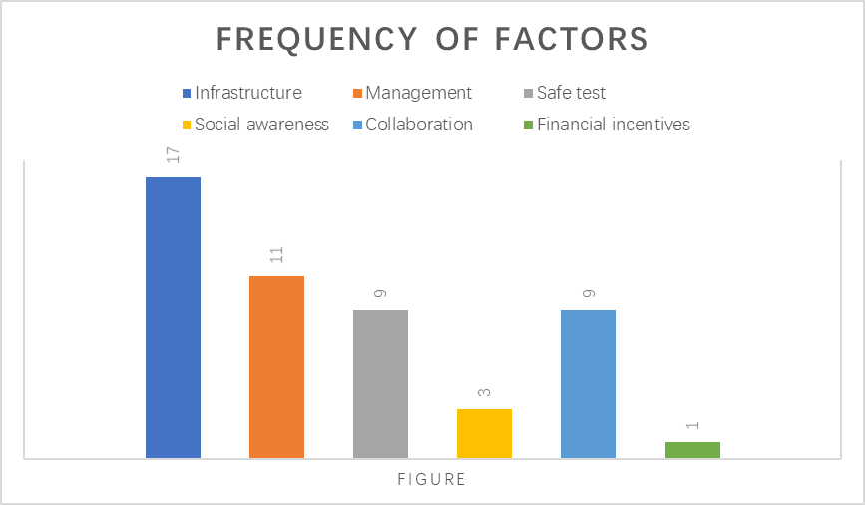

* 1. Indicators of CAV infrastructure evaluation

KMPG, a global network of professional firms providing Audit, Tax and Advisory services, claimed in its latest Autonomous Vehicles Readiness index (*2019 Autonomous Vehicles Readiness Index*, 136024-G, March 2019) that the following 6 characteristics are appropriate to evaluate the infrastructure concerning connected and autonomous vehicles.



Density of Electrical Vehicles (EV) charging station

First and foremost, density of EV charging station is considered to be an essential factor. As most AVs are expected to be EVs, their adoption will require the availability of electric charging stations. Countries with a higher density of charging stations are scored higher. Although the amount of stations in Oxford and Gothenburg are similar, difference existed in charging efficiency. Stations with high power may lack in Oxford, which would have potential threats to support quantities of CAV in future.

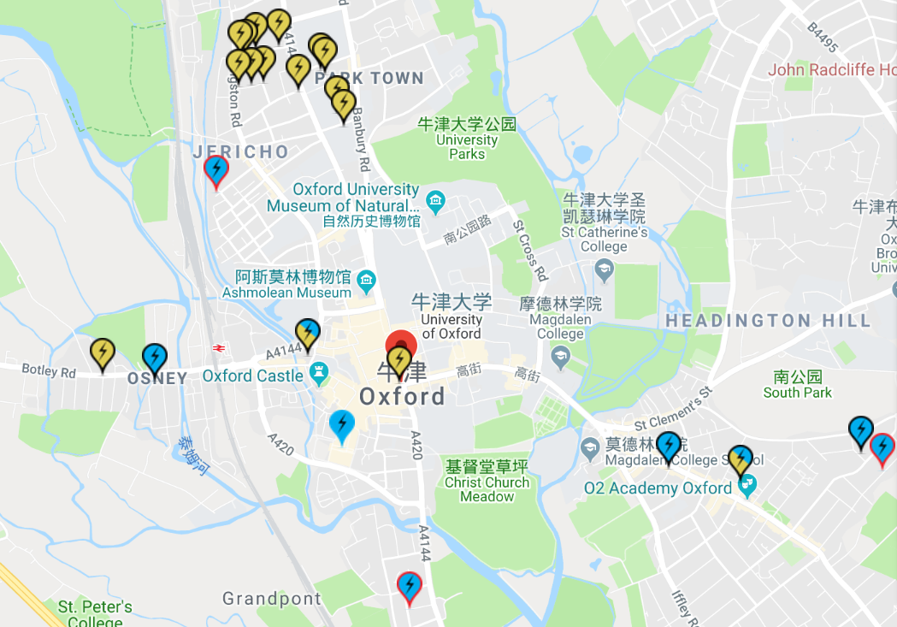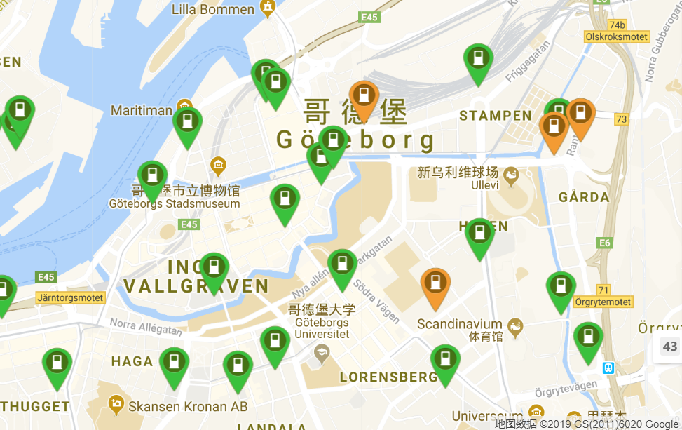

Figure 4.4-1. Distribution of charging stations in Oxford(upper) and Gothenburg <https://www.zap-map.com/live/> <https://www.plugshare.com/location/153631>

|  |  |
| --- | --- |
|  | 22kw charging station |
|  | 7kw charging station |
|  | 5kw charging station |

Table 4.4-1. Annotation of Figure 4.4-1

Quality of mobile internet

Quality of mobile internet also adapted by KMPG in this evaluation, which is assessed by the GSM Association, involving coverage, performance and spectrum of Network(*GSMA Mobile Connectivity Index*, <https://www.mobileconnectivityindex.com/#year=2018>, 2018). The figures of Sweden reflect a better condition than United Kingdom, and both are higher than the average score.

|  |  |  |  |  |  |
| --- | --- | --- | --- | --- | --- |
| Country | Network  Coverage | Network  Performance | Spectrum | 4G Availability | 4G  Speed |
| Sweden | 99.2 | 81.0 | 52.4 | 87.31% | 27.63Mbps |
| UK | 99.3 | 69.3 | 46.9 | 77.28% | 23.11Mbps |

Table 4.4-2. Score of mobile internet quality of Sweden, United Kingdom and global average from GSM Association

Mobile Connectivity Index is adapted as methods to calculate score by GSM Association. Relevance, Accuracy, Coverage and Timeliness are data selected criteria(*Mobile Connectivity Index Methodology*, 2019). After the stage of selection, data are treated with Winsorization and logarithmic transformation. To limited the score in specific range, minimum-maximum method is adopted to do normalization, thus the number can be weighted and enter aggregation process.

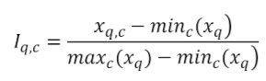

Figure 4.4-3. minimum-maximum method, ‘I’ is the normalized min-max value(lie within a range between 0 and 100), ‘x’ represents the actual value and the subscripts ‘q’ and ‘c’ represent the indicator and country respectively

4G coverage

Wide accessibility to mobile data network for autonomous vehicles is essential. Based on statistic from researcher OpenSignal, 4G availability and speed are the indicators chosen to evaluate 4G coverage in the two countries(<https://www.opensignal.com/reports/2018/02/state-of-lte>, 2018).

|  |  |  |  |
| --- | --- | --- | --- |
|  | Sweden | United Kingdom | Average |
| 4G Availability | 87.31% | 77.28% |  |
| 4G Speed/Mbps | 27.64 | 23.11 | 16.9 |

Table 4.4-1. statistic summarized from the research of OpenSignal about 4G availability and Speed.

OpenSignal collects billions of individual measurements every day from consumer devices globally. The partners of the collecting software are selected to cover a wide range of users, demographics, and devices. Measurements of network speed are based on both user-initiated tests and automated tests(certificated by official bodies including the [FCC](https://www.fcc.gov/consumers/guides/fcc-speed-test-app-tip-sheet) in the U.S.) (Federal Communications Commission, <https://www.fcc.gov/>).

To specifically display the comparison between Gothenburg and Oxford, two image are selected from Nperf(*3G / 4G / 5G in Göteborg coverage map*, Sweden, <https://www.nperf.com/en/map/SE/2711537.Goeteborg/-/signal/>, 2019)

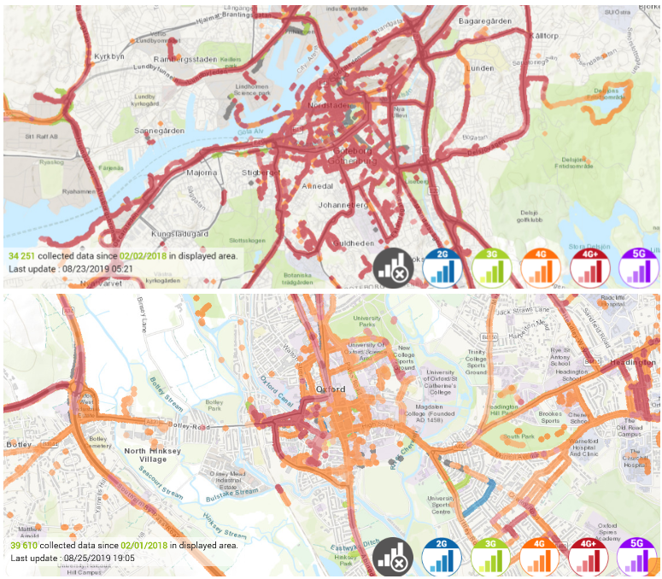

Figure 4.4-5 Quality and standard of communication in Gothenburg(upper) and Oxford(<https://www.nperf.com/en/map/SE/2711537.Goeteborg/-/signal/> <https://www.nperf.com/en/map/GB/-/24751.EE-Mobile/signal/?ll=51.72084451810049&lg=-1.2107843218836936&zoom=12>)

Logistic Infrastructure

As logistics is supposed to be a main application of future Connected and Autonomous Vehicles industry, the World Bank’s Logistic performance index 2018 (*Logistic performance index 2018*, <https://www.worldbank.org/en/news/infographic/2018/07/24/logistics-performance-index-2018>, 2018)is applied to assess this measure. The Logistics Performance Index analyzes countries through six indicators , namely efficiency of customs and border management clearance, quality of trade- and transport-related infrastructure, ease of arranging competitively priced international shipments, competence and quality of logistics services, ability to track and trace consignments and frequency with which shipments reach consignees within the scheduled or expected delivery time. The components were chosen based on theoretical and empirical research and on the practical experience of logistics professionals involved in international freight forwarding.

Generated figure maps the six LPI indicators onto two main categories. For instance, areas for policy regulation, indicating main inputs to the supply chain (customs, infrastructure, and services) and supply chain performance outcomes

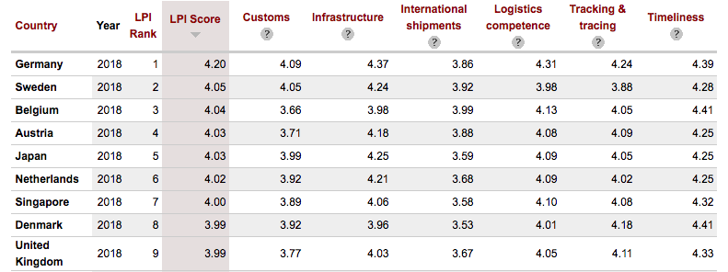

Figure 4.4-6. LPI score and other data from the World Bank’s Logistic performance index 2018

Technology infrastructure change readiness

With a number of indicators, an additional measure of the technology infrastructure that assist to support use of autonomous vehicles can be provided to partially measure the quality of technology infrastructure of countries. The displayed scores are based on KPMG International’s 2017 Change readiness index, updated for 2018.

Through the change-readiness-index(CRI) tool, scores of enterprise, government and people and civil society capability can be calculated.

Figure 4.4-7. scores about change readiness from KPMG International’s 2017 Change readiness index, updated for 2018 (<https://home.kpmg/xx/en/home/insights/2019/06/2019-change-readiness-index-tool.html>)

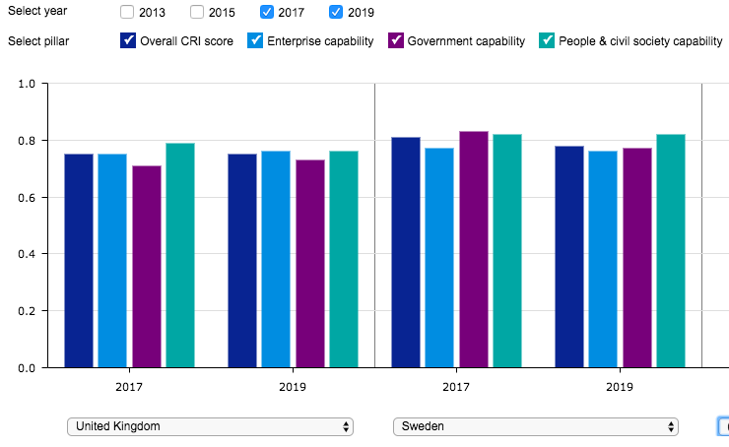

|  |  |  |
| --- | --- | --- |
|  | Sweden | United Kingdom |
| Rank | 4 | 8 |
| Strengths | Technology use  Innovation, research & development  Access to information | Land rights  Entrepreneurship  Economic diversification |
| Opportunities | Macroeconomic framework  Labor markets  Security | Enterprise sustainability  Fiscal & budgeting  Food & energy Security |

Table 4.4-3 comparison of readiness in Sweden and UK



Overall image of indicators comparison

To provide an overview of the indicators, a bar chart is applied to summary all of the difference discussed above.

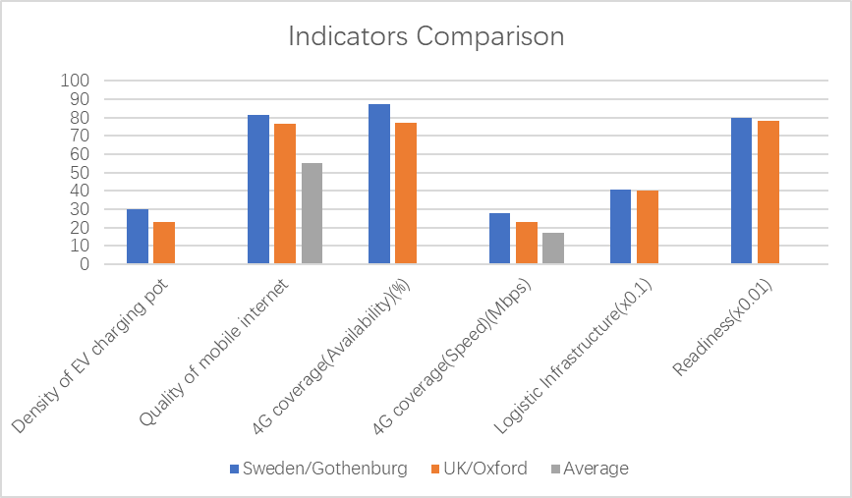Figure 4.4-8. Comparison of evaluation index of infrastructure



# Comparative study between Oxford and Gothenburg

Apart from the indicators mentioned above, a spatial analysis focused on the shared shuttle service areas in Gothenburg is added to give more comparison on microscale. Both roads and bus stations data in shapefile form is downloaded from BBBike([https://extract.bbbike.org/](https://wx2.qq.com/cgi-bin/mmwebwx-bin/webwxcheckurl?requrl=https%3A%2F%2Fextract.bbbike.org%2F&skey=%40crypt_4a100cb5_01aacf750c7534550fe473dac294ab1c&deviceid=e558783870595507&pass_ticket=Ji1WMNsKgSblfm%252BK4NRgFYXPTXbGzHeVM7o87vCPplsNdbZ%252BJaR1nbA6FBrl7n7T&opcode=2&scene=1&username=@048ed41faeb67f7b9ecc8010d3b11075cb4914b7c15195183d2efe79bb896d98), 2019) website and the original source is Openstreetmap.

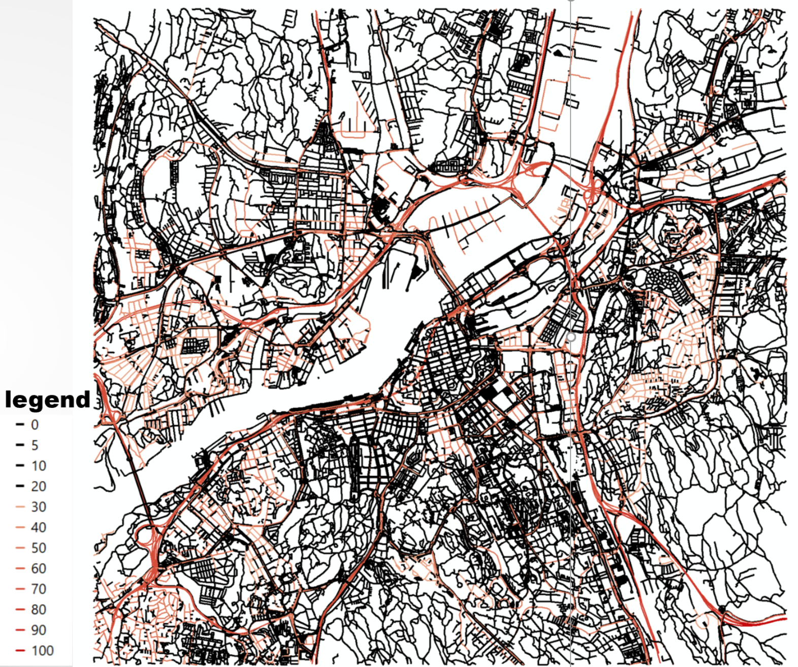

Figure 5-1. Roads condition image

The line data representing roads in all types is divided into different colour by its speed limitation attribute. With a maximum speed under 20 km/h, those lines in black is classified to be trivial and too narrow to operate CAVs. existing route in Gothenburg. For the rest, as the legend showed, colour goes darker as the driving speed’s upper limit raise.

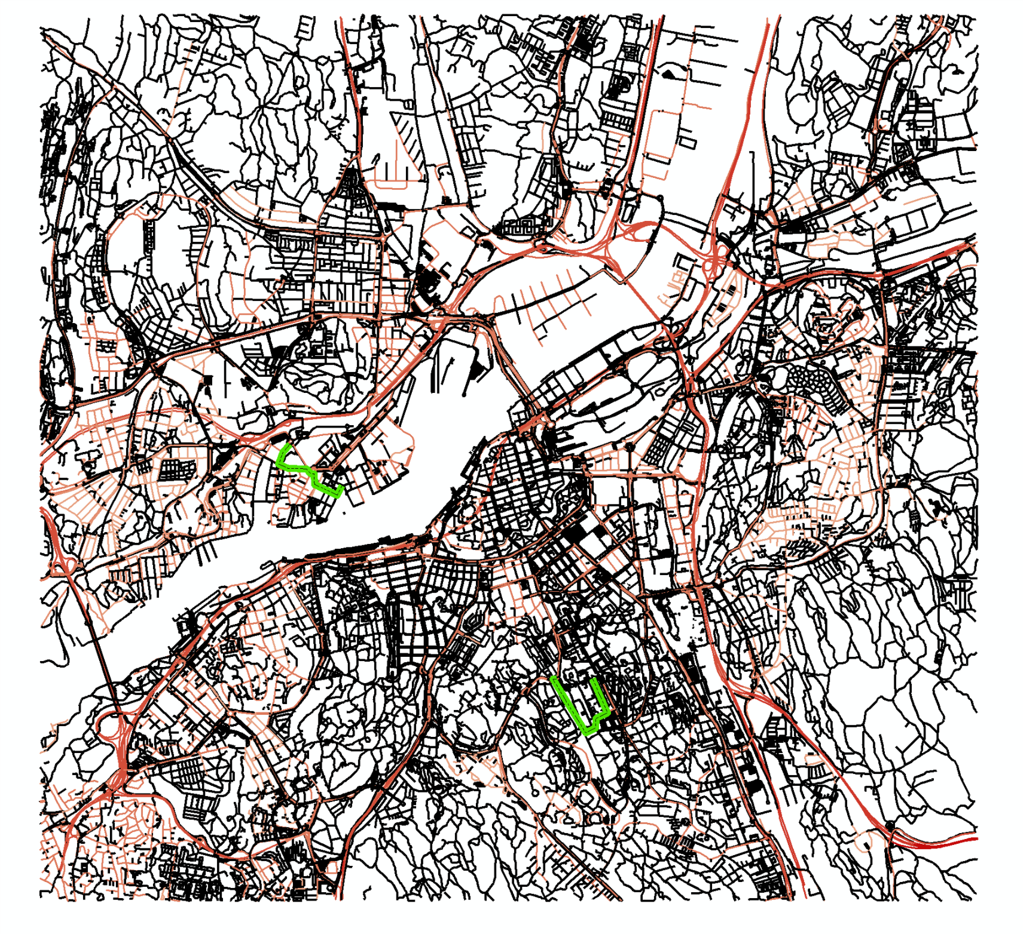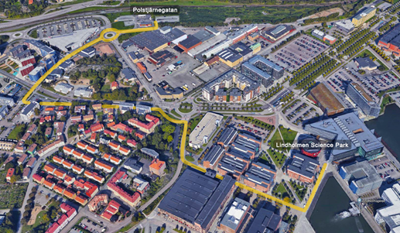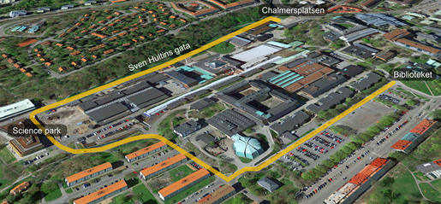

Figure 5-2. road with different speed limitation(CAV route in green)(<https://s3project.se/en/about-s3/>)

Both routes are covered in the under 50km/h regulation which is a general rule for main roads within urban areas in Gothenburg. In the UK, 30mph (approximate to 48km/h) (*speed limits UK government*, [https://www.gov.uk/speed-limits](https://wx2.qq.com/cgi-bin/mmwebwx-bin/webwxcheckurl?requrl=https%3A%2F%2Fwww.gov.uk%2Fspeed-limits&skey=%40crypt_4a100cb5_01aacf750c7534550fe473dac294ab1c&deviceid=e558783870595507&pass_ticket=Ji1WMNsKgSblfm%252BK4NRgFYXPTXbGzHeVM7o87vCPplsNdbZ%252BJaR1nbA6FBrl7n7T&opcode=2&scene=1&username=@048ed41faeb67f7b9ecc8010d3b11075cb4914b7c15195183d2efe79bb896d98))is the limitation for roads in built-up areas (unless it is near to a school or a stretch of road with sharp bends).

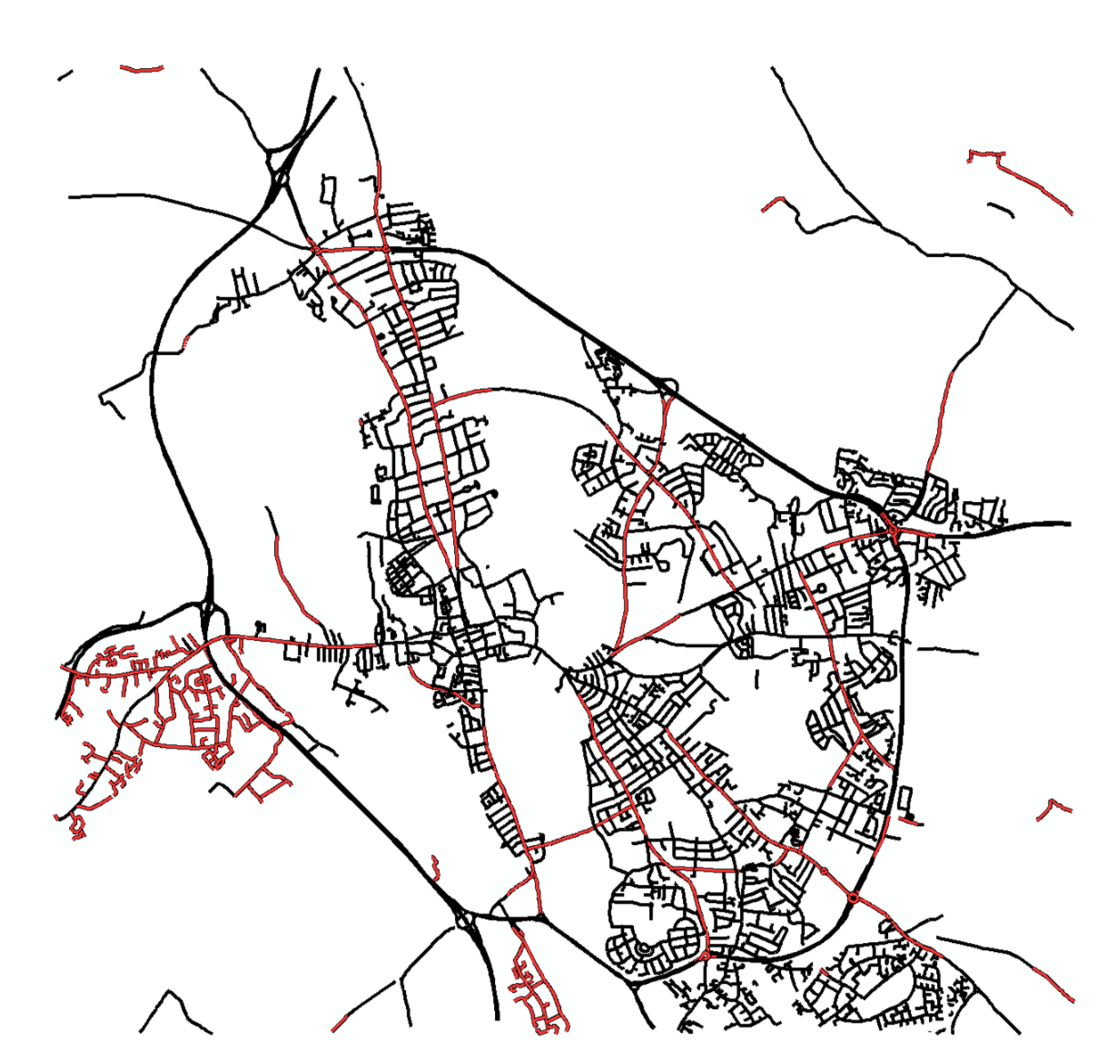

Figure 5-3.Distribution of roads with 30mph speed

Several roads are selected to this speed requirement in Oxford.

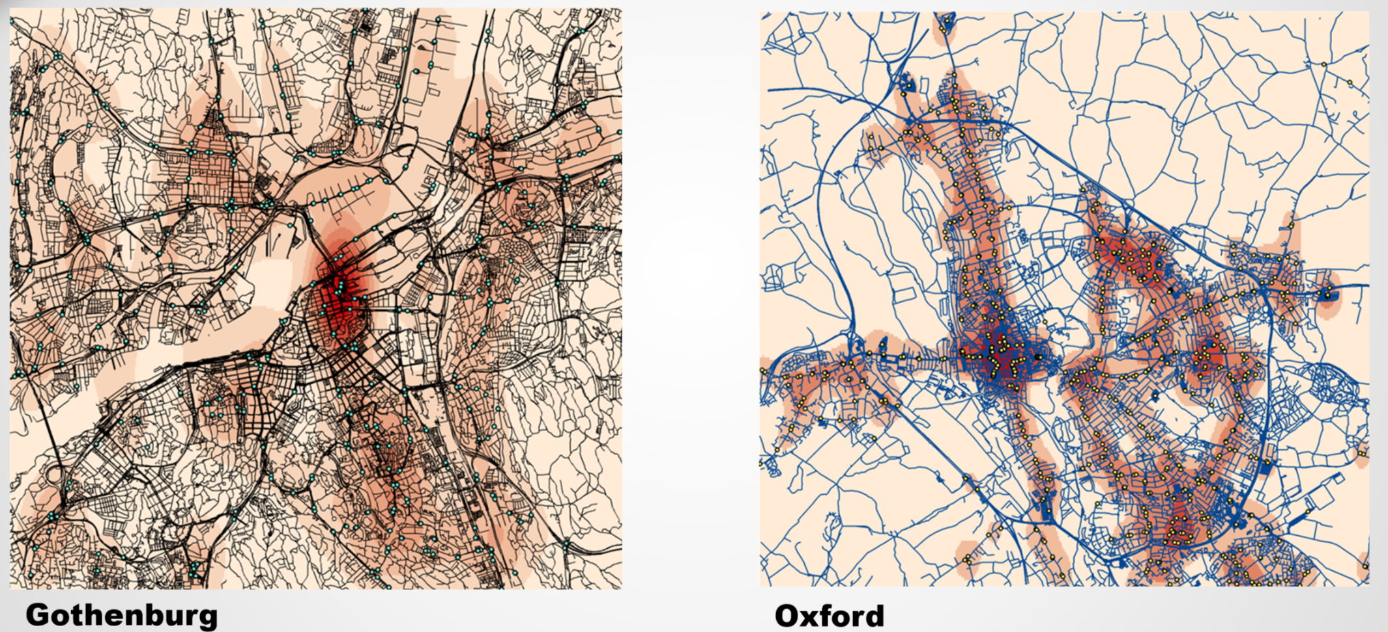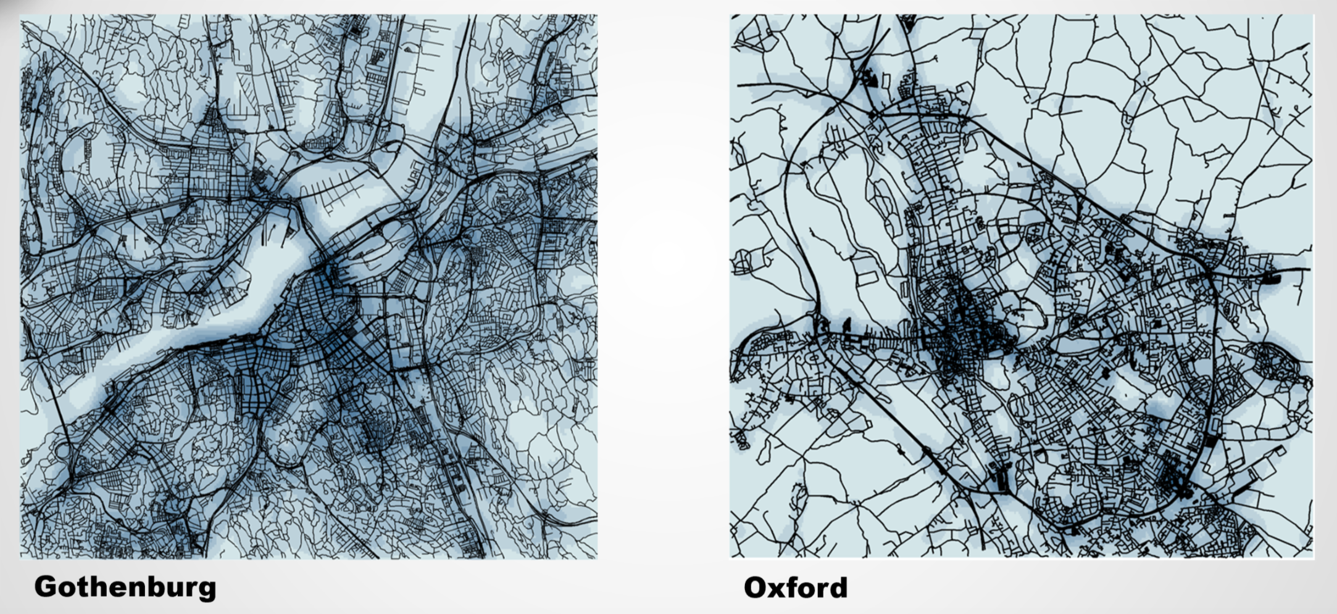

Figure 5-4.Comparison of bus station density in Oxford and Sweden

To narrow down the possible area for Oxford test site, the density of conventional bus stations and roads are compared.

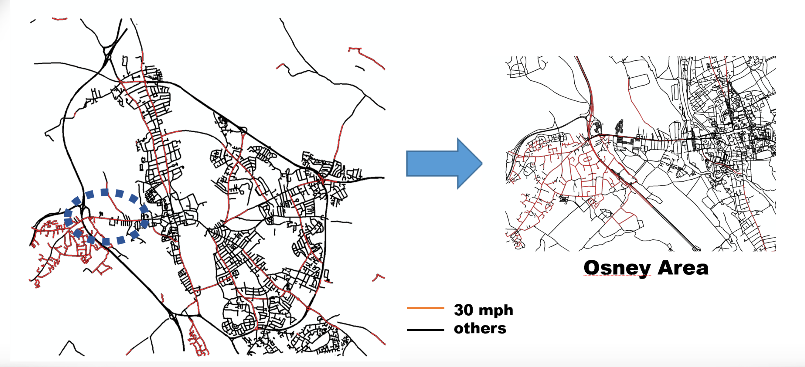

Figure 5-5. The selection of Osney Area

Therefore, Osney, a suburban community in the west of city centre, could be a nice choice for real road tests of CAVs in Oxford.

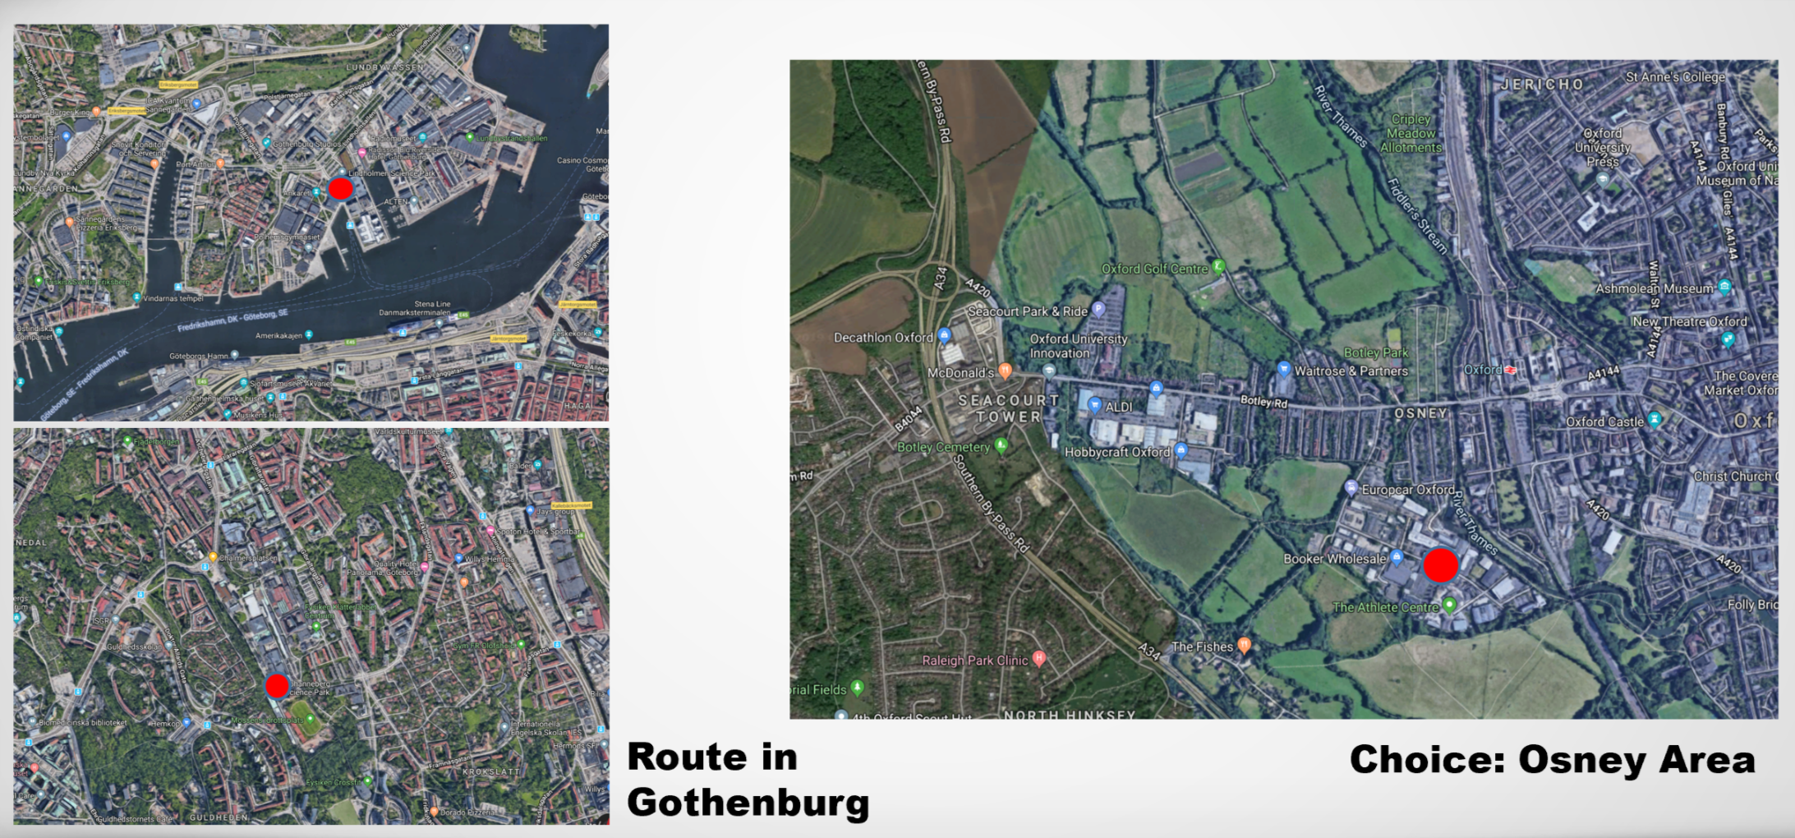

Figure 5-6. Route condition image captured by satellite

Besides, each shuttle route in Gothenburg has a science park as its key surrounding facility. For Oxford, Streetdrone(<https://streetdrone.com/>, 2019), one of the leading companies in CAVs, is in the south part of Osney. Hopefully, more and more relevant institutions will gather in this area conducting smart and safe CAV system for Oxfordshire.



# Proposal

* 1. Short term plan: 2020-2025

when it comes to the progress Oxford could take to enhance the quality of network in the near future, coverage may be offered the priority. Coverage is the factor that can guarantee the accessibility of CAV to network and connected with other infrastructure. Meanwhile, substituting 4G by 4G+ also has possibility to fulfil in short term, which indicates more effort could be put into technical area.



Due to the compact structure in Oxford, setting home-based charging station for residents living in narrow districts, is more likely a hindrance rather than help in daily travel. Therefore, the limited funds should be invested to cover most main road in public areas. Also, the commercial centre owners will be motivated when they get incentives from policy to increase fast chargers in their shopping mall.

As United Kingdom has already started to promote the 5G technique in CAV testing, direction of testing could partially lead to operational safety in next 5 years. The technology will have advantages to reduce the reaction time when referring to the emergency system project of Applus + IDIADA. For real road safety test, the idea of real-virtual environment conversion from HEADSTART could also be an aspect of Oxford safety test, which can keep more condition under control. Furthermore, cybersecurity may be another experimental direction, according to the 5stars project funded by UK government, a consumer rating framework

Since CAVs are going to expend in real road network after passing all required safety test, it is necessary to prepare enough charging stations for these new type of electric vehicles, especially in suburban areas without efficient conventional transit.

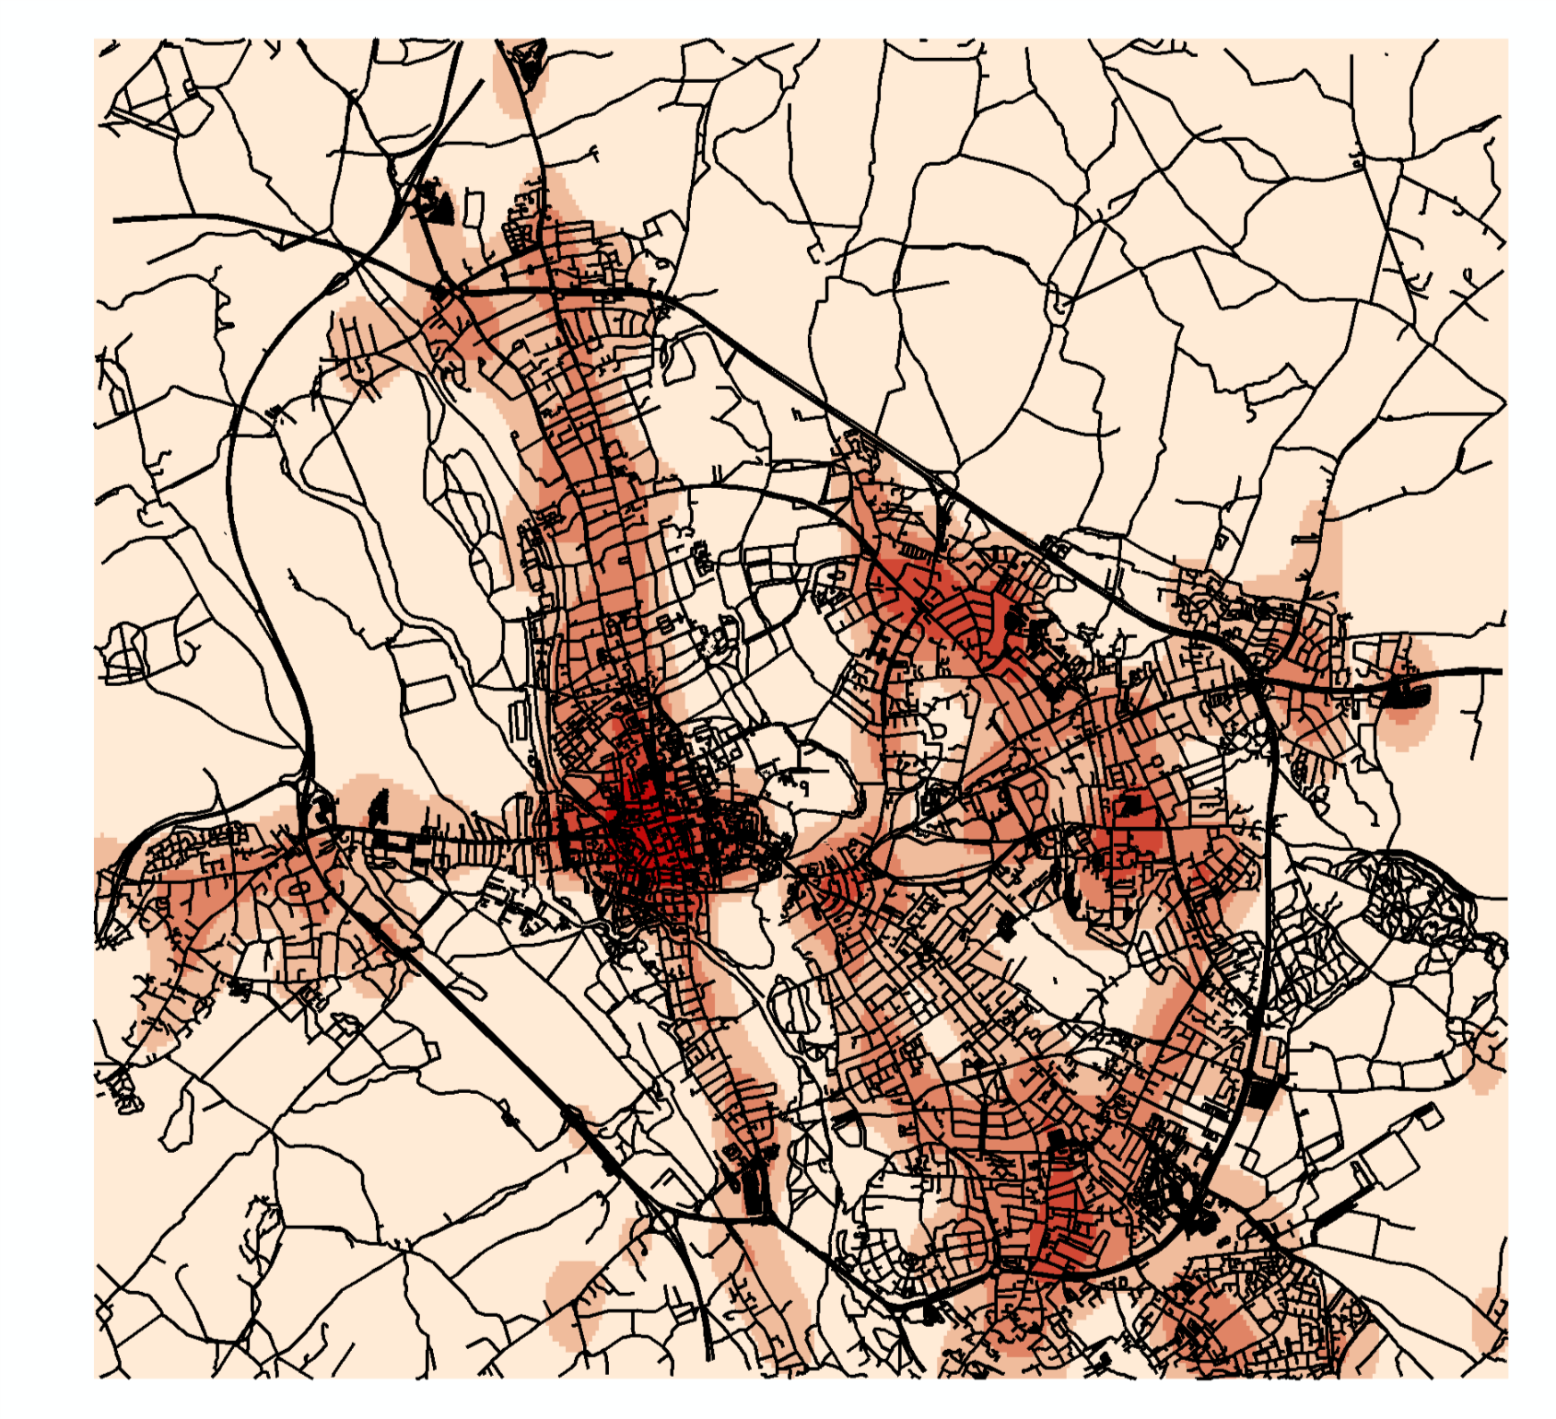

Figure 6.2-1. Density of conventional bus station

As picture above, the area in light color represents regional(suburban and exurban) areas with low density of conventional bus stations.

**Autonomous Vehicle Traffic Control Tower (AVTCT)**

Having full traffic situation awareness is a cornerstone to create safer, more efficient and environmentally friendly traffic. Real-time traffic situation monitoring on a central level is necessary, providing connected entities guidance for a better traffic control. Autonomous vehicles need a human to override the autonomous mode and take control of the vehicle, especially when it comes to public transport or emergency vehicles in critical situations. In Sweden, the AVTCT project has investigated the effects of traffic on automated vehicle and traffic management of operated fleets and public transport. The traffic control tower is actually a central system that safely and efficiently directs vehicles from multiple manufacturers to and from destinations. For different brands, they may use different onboard technologies, but they can all plug into a neutral management system. Also, the control tower can monitor and manage traffic in a way that synchronizes supply and demand to move more people through cities with fewer vehicles on the streets. (Drive Sweden, 2017)



It is suggested that Oxford can learn from Sweden to build a traffic control tower. One problem needs to be considered is that who will own and operate the control tower? Perhaps it will be some kind of third-party agency that all providers subscribe to. If providers don’t adopt some kind of supply-demand management, cities may step in and do it for them by limiting access to city centers, as cities are responsible for the quality of life and access to transit within their borders. In order to maximize efficiency, the system should include public transit for the middle-mile commutes and carefully synchronize first- and last-mile services.

* 1. Long term plan for CAVs

Traffic control tower only for CAVs is not enough. It is important to balance the relationship between CAVs and non-CAVs. Building up a comprehensive Intelligent Transport Systems (ITS) is needed in the future. ITS is a system concept relating to the use of information and communications technology within the entire field of transport. It largely involves systems, but perhaps even more so services, requiring interaction between telecommunications, electronics, information technology, traffic technology and traffic infrastructure. ITS is a complex system for different degrees of automation. This may include technical systems in the vehicle so that they interact with humans (HMI, Human Factors), and technical systems in the infrastructure so that they interact with the vehicle systems (e.g. magnetic loops in the road). Moreover, communication technology must be developed in order to facilitate interaction between the systems, like Vehicles to Vehicles(V2V), Vehicles to Infrastructure (V2I). Humans and technology in the entire system must be capable of interacting and operating in fast traffic situations which are difficult to predict. (Swedish Transport Agency, 2014)

# Conclusion

Aim of the report is to analyse the progress that Sweden has done to CAV, select the outstanding projects and policy and summed up the proposal we expect to submit to assist Oxfordshire City Council in formulation of CAV future plan. In the whole process. Moreover, methods like compare study, GIS analysis and mathematic operation are adapted to display the scientific part of report. Meanwhile, a quantity of criteria selected with authoritative reference is applied to promote the process of comparison.

# References and Bibliography



[1]Applus+IDIADA. Available: <https://www.applusidiada.com/en/>. [Accessed: August 2019].

[2]AstaZero[Active Safety Test Area and Zero]. Available: <http://www.astazero.com/>. [Accessed: August 2019]

[3]Department for Transport, *The Pathway to Driverless Cars: Summary report and action plan*, ISBN 978-1-84864-153-2, 20 December 2016.

[4]GSM Association, *GSMA Mobile Connectivity Index*. Available: <https://www.mobileconnectivityindex.com/#year=2018>. [Accessed: August 2019].

[5]HEADSTART[Harmonized European Solutions for Testing Automated Road Transport]. Available: <https://www.headstart-project.eu/> . [Accessed: August 2019].

[6]KPMG International Cooperative, *2019 Autonomous Vehicles Readiness Index*, 136024-G, March 2019, Available: kpmg.com/avri.[Accessed: August 2019].

[7]S.N., *Why Sweden has so few road deaths*, The Economist (2014), 26 February 2014. Available: <https://www.economist.com/the-economist-explains/2014/02/26/why-sweden-has-so-few-road-deaths>. [Accessed: August 2019].

[8] Swedish Transport Agency, Autonomous driving pilot study, 2014. Available: <https://www.unece.org/fileadmin/DAM/trans/doc/2014/wp1/Autonomous_driving_pilot_eng.pdf>. [Accessed: August 2019].

[9]Drive Sweden, Autonomous Driving Aware Traffic Control—Final Report, 2019. Available:<https://www.drivesweden.net/sites/default/files/content/ad_aware_traffic_control_-_final_report_v11_0.pdf> .[Accessed: August 2019].

.

**Appendix**

|  |  |  |
| --- | --- | --- |
| Project name | Introduction | Remarks |
| Autopilot in Barkaby（2018-） | The project develops new technology and provides the rapidly growing Barkarby town and its inhabitants with a first/last mile solution for transport. | Autonomous buses have been running on a regular schedule for the service providers since October 2018.  Using "ordinary" app for public transport with timetable and payment solution. |
| Autopilot in the Nordic countries（2018-） | The project in Kista will be a supplement to established public transportation for the purpose of improving accessibility – in short, facilitating everyday door-to- door travel. | The first driverless buses runs for six months and involve two buses, each of which carries 11 passengers and a “conductor.” |
| Shared Shuttle Services (S3)  （2018-） | The S3 (Shared Shuttle Services) Team has been working to get our living experiment with self-driving buses in place. An important part of the attempt is to investigate how you, as a traveler, experience autonomous transport. | A self-driving minibus with space for 10 passengers is being tested in Gothenburg. The first route ran between three stops adjacent to Chalmersplatsen, Johanneberg Science Park and the library. Another route runs between Polstjärnegatan and Lindholmen Science Park. |
| KOMPIS（2018-） | Combined mobility as a service means transport in range between e.g. autonomous vehicles, public transport, car pools and rental bikes and the common principle is shared transport, efficient energy utilization and smooth transitions. |  |
| Autonomous transport system  (1 August 2016 – 31 Mars 2017) | The project is about a wide collaborating on the challenges of the city, and based on these, find values ​​and a common picture about what we are facing. | The co-creation lab itself is a full-day exercise with people from business and academia, as well as the city and other public activities. The Drive Sweden network is an important participant, and also the city's planning administrations. |
| AVTCT  (December 2017 - November 2018) | The goal of the project is to understand the role of a traffic control tower (TCT) for automated road vehicles (AVs). | A pre-study was performed in order to understand the required functionalities and roles of the tower, its possible design and layout, and the opportunities that the control tower provides to increase safety and efficiency of AV fleet operation. |
| CAT (October 2018 – September 2019) | In the CAT project, solutions for connected driverless electric freight transport are tested and demonstrated. | The project is executed in three work packages:  WP1 – Technical trials on test track  WP2 – Pilot trials in traffic  WP 3 – Extended ecosystem and demonstrations  The project will demonstrate how driverless truck transport can be enabled by enhanced connectivity based on 5G, connected services and ecosystem and remote operation of vehicles. |
| HUGO (2018-2019) | The project aims to investigate, develop a prototype and evaluate the potential of using smaller autonomous electric vehicles to perform last mile deliveries of packages and goods. | The HUGO prototype is based on a modular design where all sensors for driving autonomously are in the chassis. |
| Automated logistics services | By looking into different cases related to the handling of goods, collection of data and connection of goods, load carriers and vehicles, this pre-study aims to identify specific areas where efficiency could be improved by automation and also what other benefits automation can provide. |  |
| ART  (2016-2017) | The project aims to investigate and analyze current conditions and trends for semi-automated and / or fully automated trucks and robots in urban environments within the waste and recycling area for operations both in Sweden and the rest of Europe. | The project also intends to identify which areas in waste management are most interesting for automation and which services can be linked to different technologies. |
| Advanced Cooperative Driver Assistance  (2019-2020) | The project will test and demonstrate central cloud-based traffic management system which compiles information and coordinates the information exchange with and between connected vehicles. | The system will be connected to both autonomous vehicles (Volvo Cars AD vehicles) and vehicles equipped with advanced driver support (CEVT ADAS vehicles). The work will further develop the cloud based platform produced in the project ”AD Aware Traffic Control” which in turn was complemented by the project ”AD Aware Traffic Control – Emergency Vehicles”. |
| Interlink  (2017-2018) | The project is aimed at optimizing resource utilization of automated transport modes by connecting and linking them with existing public transport. For example, cloud-based transport network provides recommendations on the dynamic departures of automated vehicles, connected through e.g. Drive Sweden Innovation Cloud (DSIC). | Within the project, a work package is aimed at building an advanced traffic data API, which will enable logical functionalities and prepare integration of various automated transport modes used in a number of test sites around the world, including Test Site Stockholm where AD vehicles will be commissioned. In addition, the project also focuses on expanding and raising traffic data content within Drive Sweden with the best available GIS and real-time data from PTA to improve the prerequisites for Test Site Stockholm. The project is also aimed at deploying a full-scale test environment at ITRL at KTH. |
| Traffic management of emergency vehicles (2017-2018) | AD Vehicles share position with Emergency Vehicle Coordinators and receive information about Emergency Vehicles’ positions and/or Most Probable Path(MPP). Allowing AD Vehicles or OEM Traffic Control to take appropriate action: either revoke AD Approvalor, in the future, guide AD vehicles to move out of the MPP so the Emergency Vehicles can pass. |  |

Table 1 Projects in Sweden

|  |  |  |
| --- | --- | --- |
| Policy/project | Introduction | Remark |
| **Gothenburg Comprehensive Plan** | The Comprehensive Plan shows how the municipality wants land and water areas to be used and  provides guidance for decisions by the City Council. This plan focuses on the ways in which sustainable growth can occur and how it is expressed in the decisions. | **Autonomous Vehicles as part of comprehensive plan for city center**  Aim: Examining the negative and positive impact of autonomous vehicles in relation to the physical planning of the city.  **Framework**  • Prerequisites and assumptions: need for more knowledge, assume that technology work)  • Scenario with two time frames 2035 and beyond 2050  • Overall infrastructure for the central Gothenburg  • institutions and laws support  • Impact on urban planning, opportunities and obstacles: New types of energy will benefit the urban environment  • Overall recommendation for land use, how to contribute to the attractive city  • Conflict of interests  • Goods are transported by AVs |
| **Development strategy Gothenburg 2035** | The Development Planning Strategy 2035indicates which locations have particularly good conditions for sustainable urban development. This will be achieved by making the already built environment denser through new construction.  The strategy for the development plans focuses on the interlinked city area outside of the city centre that has good public transport | **Development aim**: Continued planning in the city of Gothenburg shall primarily focus on supplementing the built-up city in combination with building in strategic nodes.  The city contains buildings and areas with very different characters. This means that they need to be supplemented in many different ways. The basic idea is to retain and reinforce the existing qualities. When building ad­ditional structures, it is important to take into account poten­tial conflicts such as noise pollution, risk issues and access to green areas.  **The order of development**: build the city from the centre outwards. In the central renewal areas, a more compact city will be developed |
| **Gothenburg 2035 transport strategy** | The strategy indicates how the transport system needs to be developed as more people live, work, shop, study and meet in the city. Focus on how the transport  system and streetscape in Gothenburg are to be developed in order to  achieve set objectives and meet the challenges facing the city. | planning concept: access through rapid mobility + access through short distances  **Implementation principle:**   * **Making more efficient use of roads and streets (use):** Information and control and management of road traffic in combination with measures to limit the number of vehicles in the transport system will ensure good accessibility for all road users and goods transport. * **Creating a denser and more interconnected network of streets without barriers (structure):** Navigability, route efficiency and the absence of barriers in the street network make it easier to move around, thus consolidating the city and spreading urban life to more places. The dense and interconnected street network exists for all modes of transport, as long as flows and speeds do not create new barriers. * **Ensuring good accessibility for goods transport in Gothenburg while at the same time reducing negative local environmental effects:** Increased rail network capacity and prioritisation of freight traffic on designated routesnot only improves accessibility for goods but also allows effective measures to be implemented to reduce the effects of noise, emissions and barriers. Optimising the choice of transport and the use of combined transport increase efficiency and reduce climate impact. |
| **Gothenburg 2035 green strategy** | The green strategy for a dense and green city indicates how Gothenburg can remain and develop further as a city with considerable green qualities, from both a social and an ecological perspective, while at the same time being made more dense through new construction. | Development aim: to show how Gothenburg may remain and further develop as a city with major green qualities from a social and ecological perspective, whilst building gthe city more close-knit.  Gothenburg will develop into a lively, sustainable city with a good balance between social, economic and environmental factors |
| DriveMe | DriveMe is the world’s first large-scale pilot project in autonomous driving where 100 self-driving Volvo cars will be driven on public roads in Gothenburg. | Aim: to study the benefits to society of autonomous driving and for Sweden and Volvo Cars to become a leader in sustainable mobility.  Focus areas:   * How autonomous vehicles can generate social and economic benefits in the form of improvements in traffic flows, environment and safety. * Infrastructure specifications for autonomous driving. * Which traffic situations are appropriate for self-driving vehicles. * The customer’s confidence in self-driving vehicles. * How other drivers can be integrated with a self-driving car. |
| SARTRE project | SARTRE (Safe Road Trains for the Environment) is an EU-financed research project, which is looking at inexpensive ways of getting vehicles to travel in a ‘platoon’ on Europe’s motorways. | The project use wireless technology to facilitate communication between the lead and following vehicles. Each vehicle in the platoon is equipped with a human-machine interface (HMI), in which the platoon’s Organisation Assistant (OA) software is running. |

Table 2 Gothenburg related policies and projects

|  |  |  |  |  |
| --- | --- | --- | --- | --- |
| HEADSTART | Aim | Define testing and validation procedures of connected and autonomous driving functions including key technologies such as v2x communications, cyber-security and positioning(three significant characteristics for safety reliability). | | |
| Definition | Harmonized European Solutions for Testing Automated Road Transport. An EU funded project with 17 members | | |
| Duration | 01.2019 – 12.2021 (36 months) | | |
| budget | 6M€ | | |
| characteristic | Set in both simulation and real-world fields to validate safety and security performance according to the key users’ needs. | | |
| Assessment | Creation of assessment protocols increasing vehicle safety awareness | | |
| Testing and validation | Identify->Harmonize->Define & Develop->Demonstrate->Reach consensus | | |
| Certification | Generation of regulations ensuring the safe introduction of CAD technologies to the market | | |
| Three Key Enabling Technologies | Cybersecurity | operation | Transference from other domain. |
| test | At least one Use Case allowing to apply developed cybersecurity assessment procedures/tests in HEADSTART. |
| v2x communication | Methodology | Integration of V2X communication into CAD scenario tooling & Analyze and elaborate available v2x technologies & Identify using cases. |
| test | Use case(s) allowing to apply developed V2X communication assessment tests in HEADSTART. |
| Positioning | Methodology | Unified testing methodology & Expert Group network & Classification of Positioning module |
| test | Evaluation of minimum performance of the systems keeping under control all the testing conditions & Record and Replay tests to monitor real life conditions |
| Example of coordinators | Applus + IDIADA | condition | Already start the construction of its new test track for Connected and Automated Vehicles (CAV) between February and March 2019. |
| project | vehicle-to-vehicle emergency braking systems |
| pedestrian detection systems |
| lane departure warning systems |
| lane keeping assistants |
| automatic braking systems for animal crossing |
| AstaZero | Design of Site | |
| Bi-directional traffic Right-hand traffic Road width of 7 metres | |
| Active Safety | active safety is about  avoiding collisions and other incidents before they happen |
| For climate: AstaZero’s location enables year-round testing that can evaluate Reliability of system and the performance of sensors. |
| Test focus | Driver Behaviour(detect with electric control). |
| Test Methods for False Alarms. |
| Crash Contact Point Optimization(optimise the benefits of airbags and seatbelts and the efficacy of structural means of absorbing crash energy) |

Table 3 operational safety test details